Get security error:

Set-ExecutionPolicy -Scope Process -ExecutionPolicy Bypass

=============================

https://www.udemy.com/course/complete-reactjs-masterclass/learn/lecture/35501166#content

https://react.dev/learn/writing-markup-with-jsx

Below and Autoimport and intellicode and materialicontheme also install

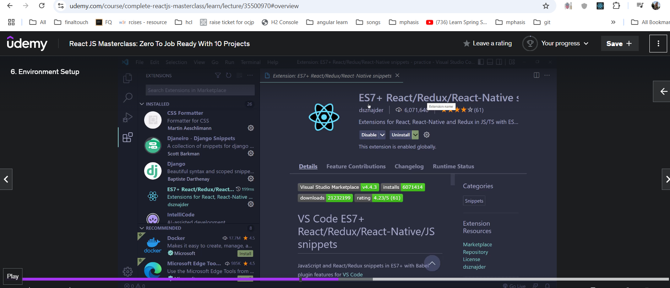

Settings->emmet include lang 🡪key🡪javascript & value🡪javascriptrect as value

C:\Users\Mr\Desktop\reactjs\taskmate 🡪 code . aunte taskmateproject ni vs code lo shown.

Jsonserver:

<https://github.com/typicode/json-server>

step 1: npm install json-server

step 2: Create a db.json

step 3: db.json is exist inside data folder then give below command.

Json server –watch /data/db.json –port 8000

useEffect();🡪loaded once not multiple times from backend api.

Its call 2times ..mount and unmounts..

Collections lo data ela iterate aunte..

  {

            products.map((p)=>(

                <p>{p.name}</p>

            ))

  }

=====================================

How to create customhook?

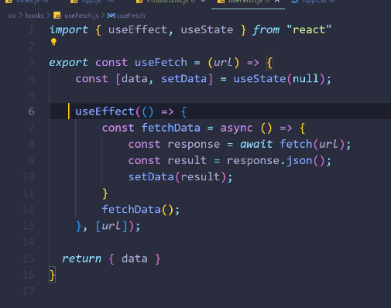

useEffect( ()=> {}, []);

https://github.com/ShubhamSarda?tab=repositories

Redux: <https://react-redux.js.org/tutorials/quick-start>

https://codesandbox.io/p/sandbox/github/reduxjs/redux-essentials-counter-example/tree/master/?file=%2Fsrc%2Fapp%2Fstore.js%3A4%2C1-8%2C4&from-embed

Below 3 concepts are required.

• **Actions**: Describe what should happen (e.g., { type: 'INCREMENT' }).

• **Reducers**: Specify how the state changes in response to actions.

• **Store**: Holds the global state of the application.

Reducer : state modify

Action : having route path and payload(data)

Lets start the example:

Step 1 : npm install @reduxjs/toolkit react-redux

Step 2: create redux store

### Step 3 : Provide the Redux Store to React[​](https://react-redux.js.org/tutorials/quick-start#provide-the-redux-store-to-react)

### Step 4: Create a Redux State Slice[​](https://react-redux.js.org/tutorials/quick-start#create-a-redux-state-slice)

### //createSlice() having name,initialstate,reducersfunction

### //import createslice as actions,reducer

### Step 5: Add Slice Reducers to the Store[​](https://react-redux.js.org/tutorials/quick-start#add-slice-reducers-to-the-store)

### Step 6: Use Redux State and Actions in React Components[​](https://react-redux.js.org/tutorials/quick-start#use-redux-state-and-actions-in-react-components)

### //We can read data from the store with useSelector, and dispatch actions using useDispatch.